MACHINE PROBLEM 2 (MATLAB)

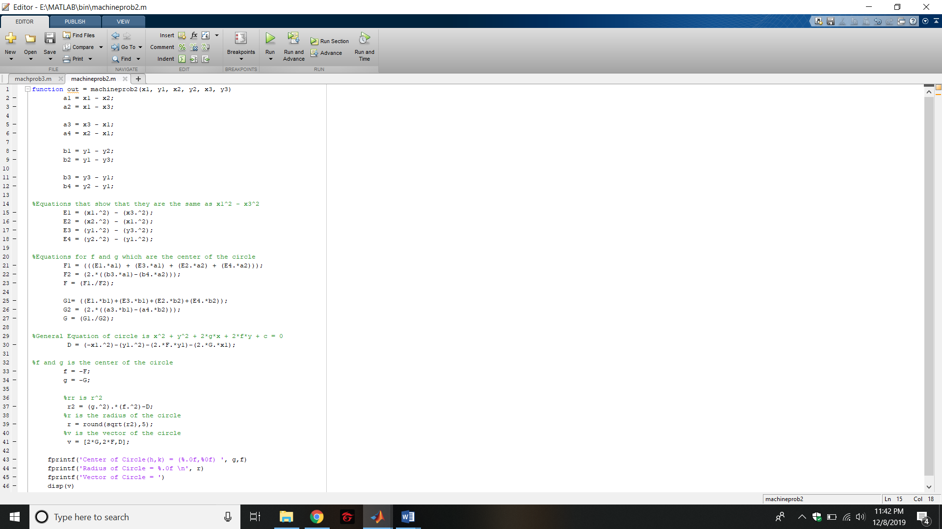

PROOF OF TESTING

